VISVESVARAYA TECHNOLOGICAL UNIVERSITY

“JNANA SANGAMA” , BELAGAVI-590018, KARNATAKA



Project (18CSP77) Report
On

S
“QUALITY ANALYSIS AND SHELF-LIFE PREDICTION OF FRUITS USING DEEP LEARNING FOR
AUTOMATED STORAGE SORTING”

Submitted in the partial fulfillment of the requirement for the award of degree of

BACHELOR OF ENGINEERING IN
COMPUTER SCIENCE AND ENGINEERING

Submitted By

Vaishnavi A | 1VA18CS053
Santhosh K | 1VA18CS039
Suhas M | 1VA18CS048
Tejas Manu S | 1VA18CS052

Under the Guidance of
Prof. Kshama S B
Assistant Professor,
Dept. of CSE, SVIT
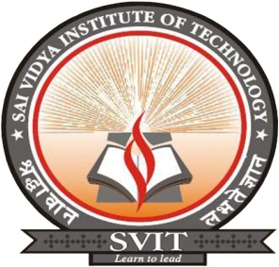

DEPARTMENT OF COMPUTER SCIENCE AND ENGINEERING
Accredited by NBA, New Delhi
SAI VIDYA INSTITUTE OF TECHNOLOGY
(Affiliated to Visvesvaraya Technological University, Belagavi | Recognized by Govt. of Karnataka | Approved by AICTE, New Delhi)
RAJANUKUNTE, BENGALURU – 560 064
2021-22

